**Creating new project using Pychar**

* **File** (Menu) > **New Project**

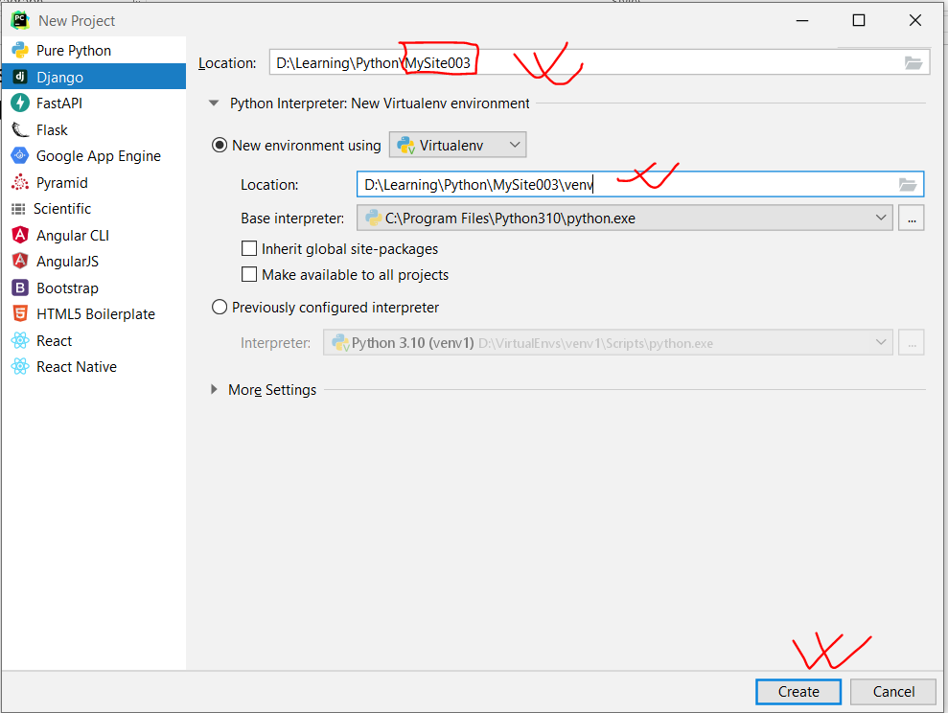

* Project Name (Path\MySite003)
* New Environment using (Virtualenv) (Auto path)
* Click on **Create**

**Explore Django Project**

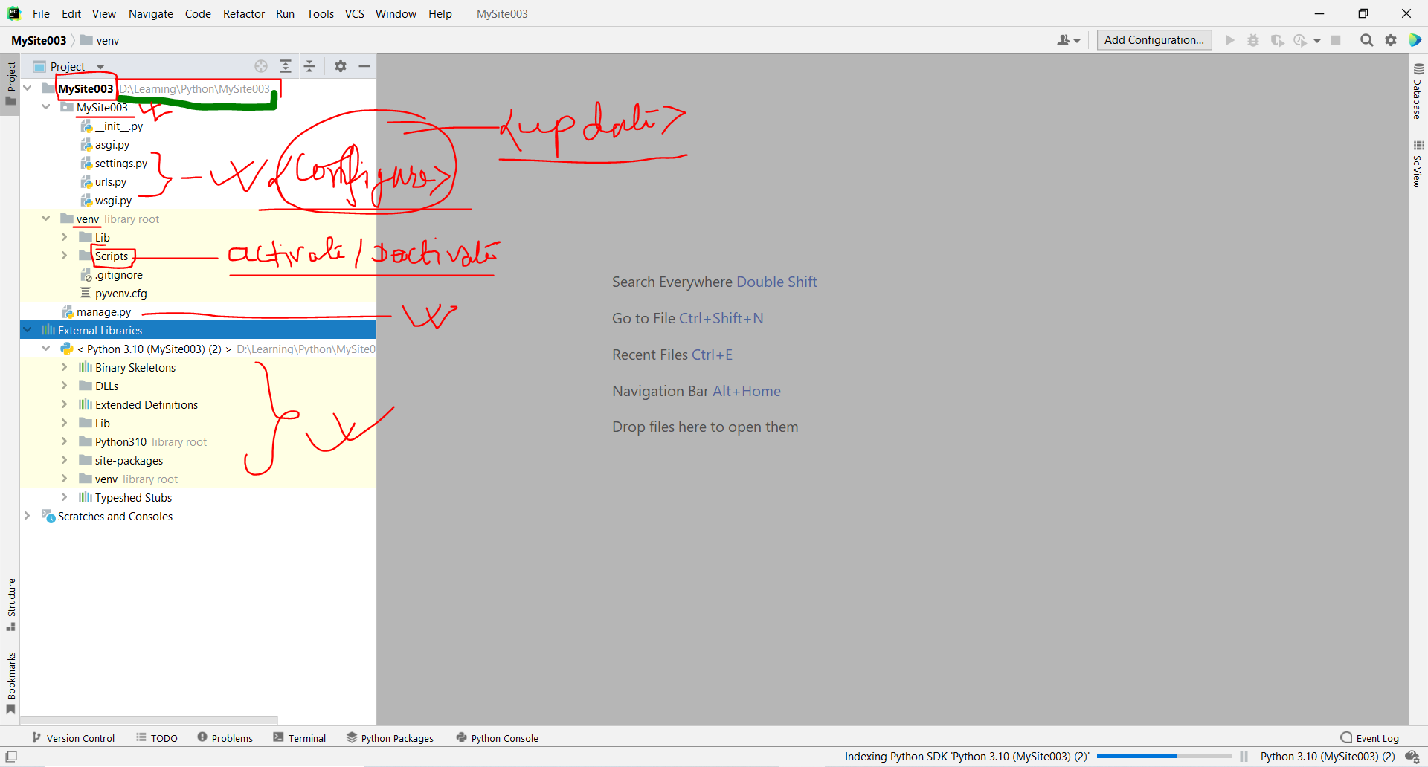

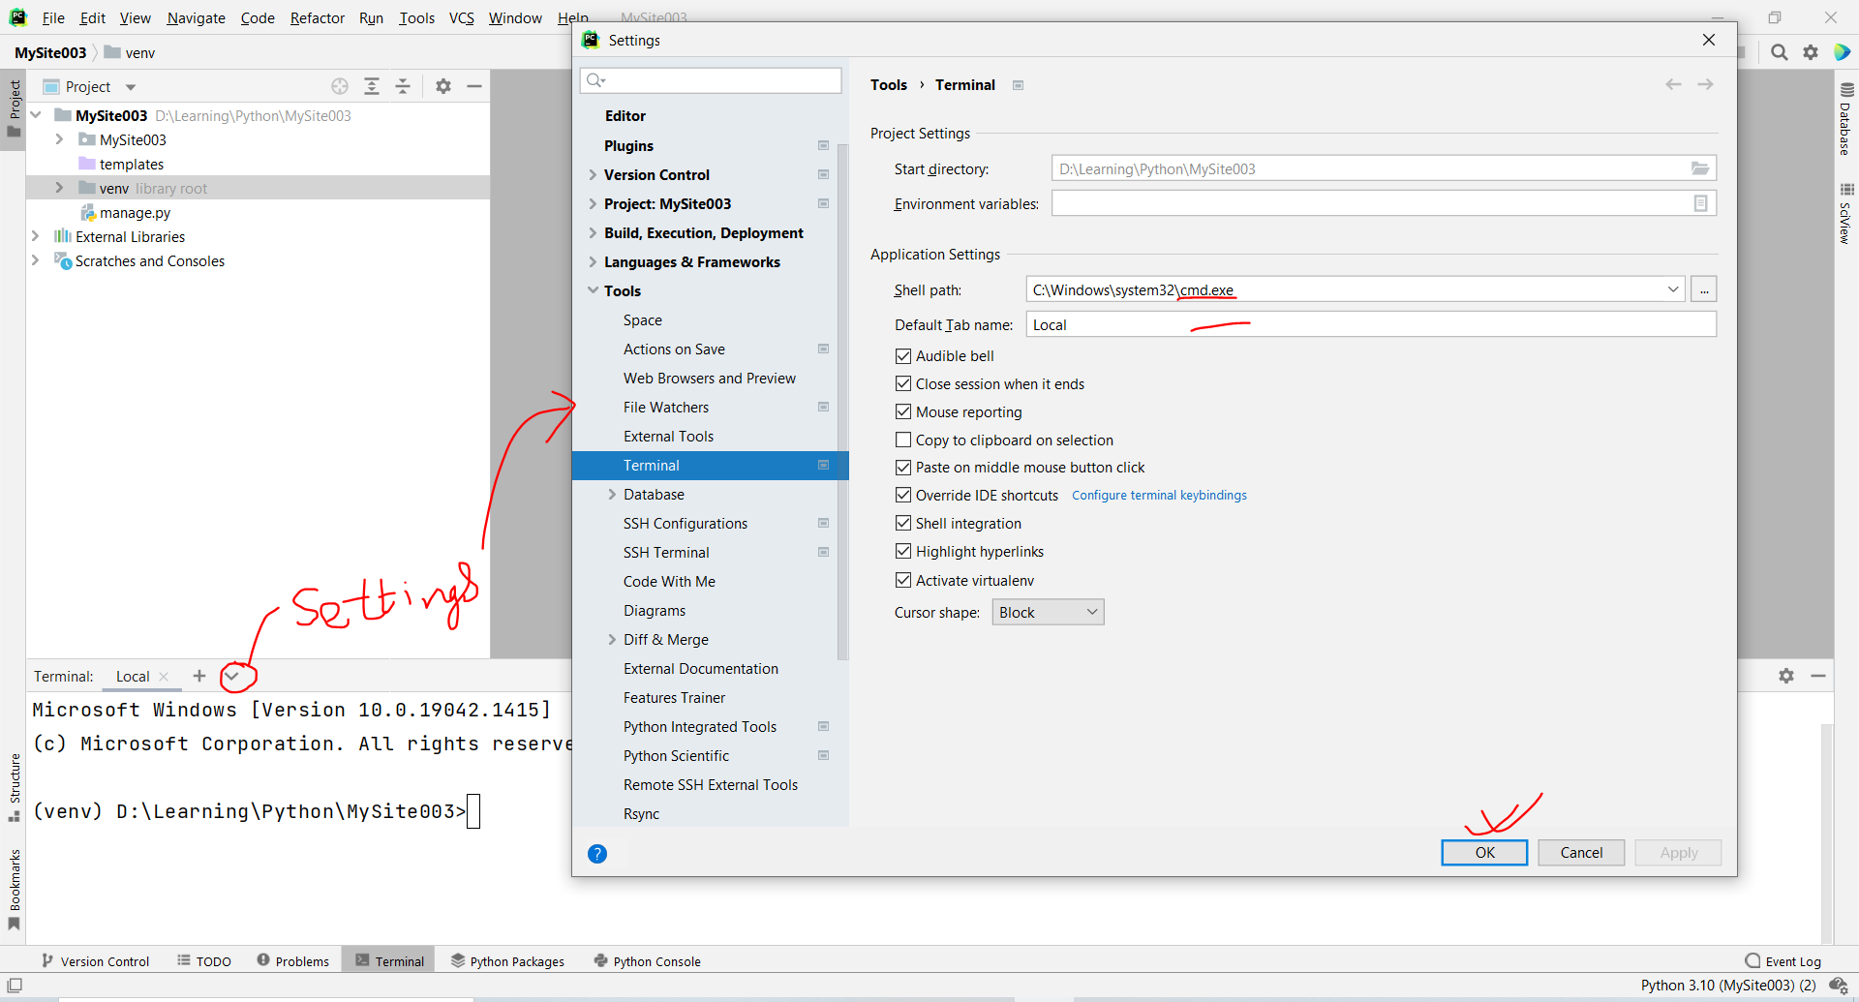

**Server up/down**

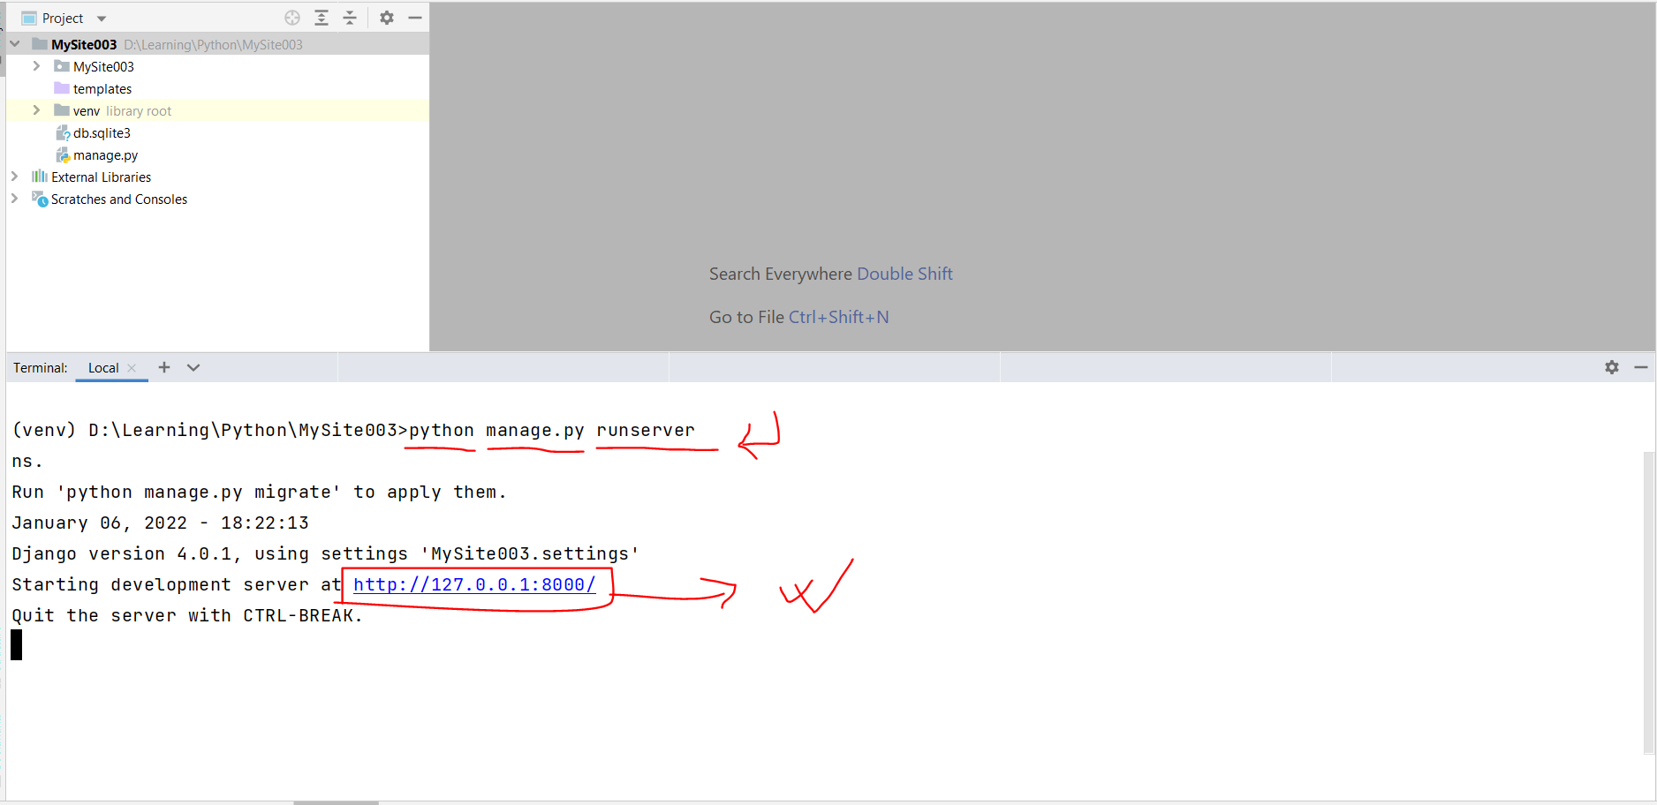

**Browse Site**

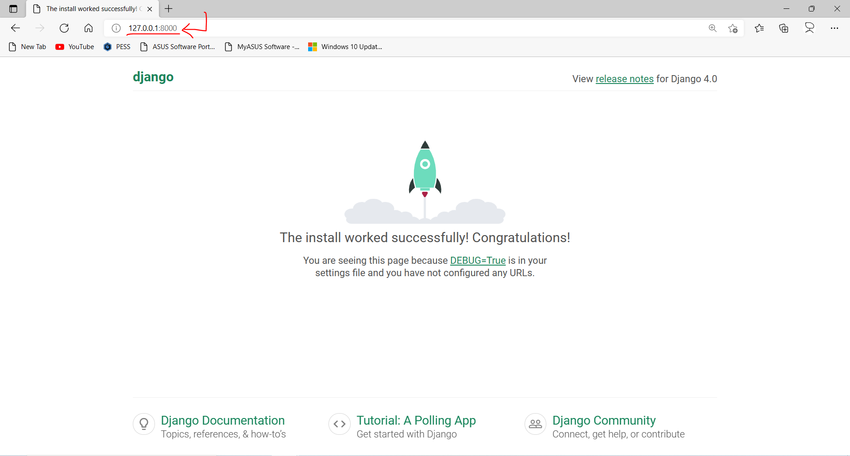

**Creating own view (Hello world of Django)**

* Create a new python file (MySite003\views.py)

**Server Down**

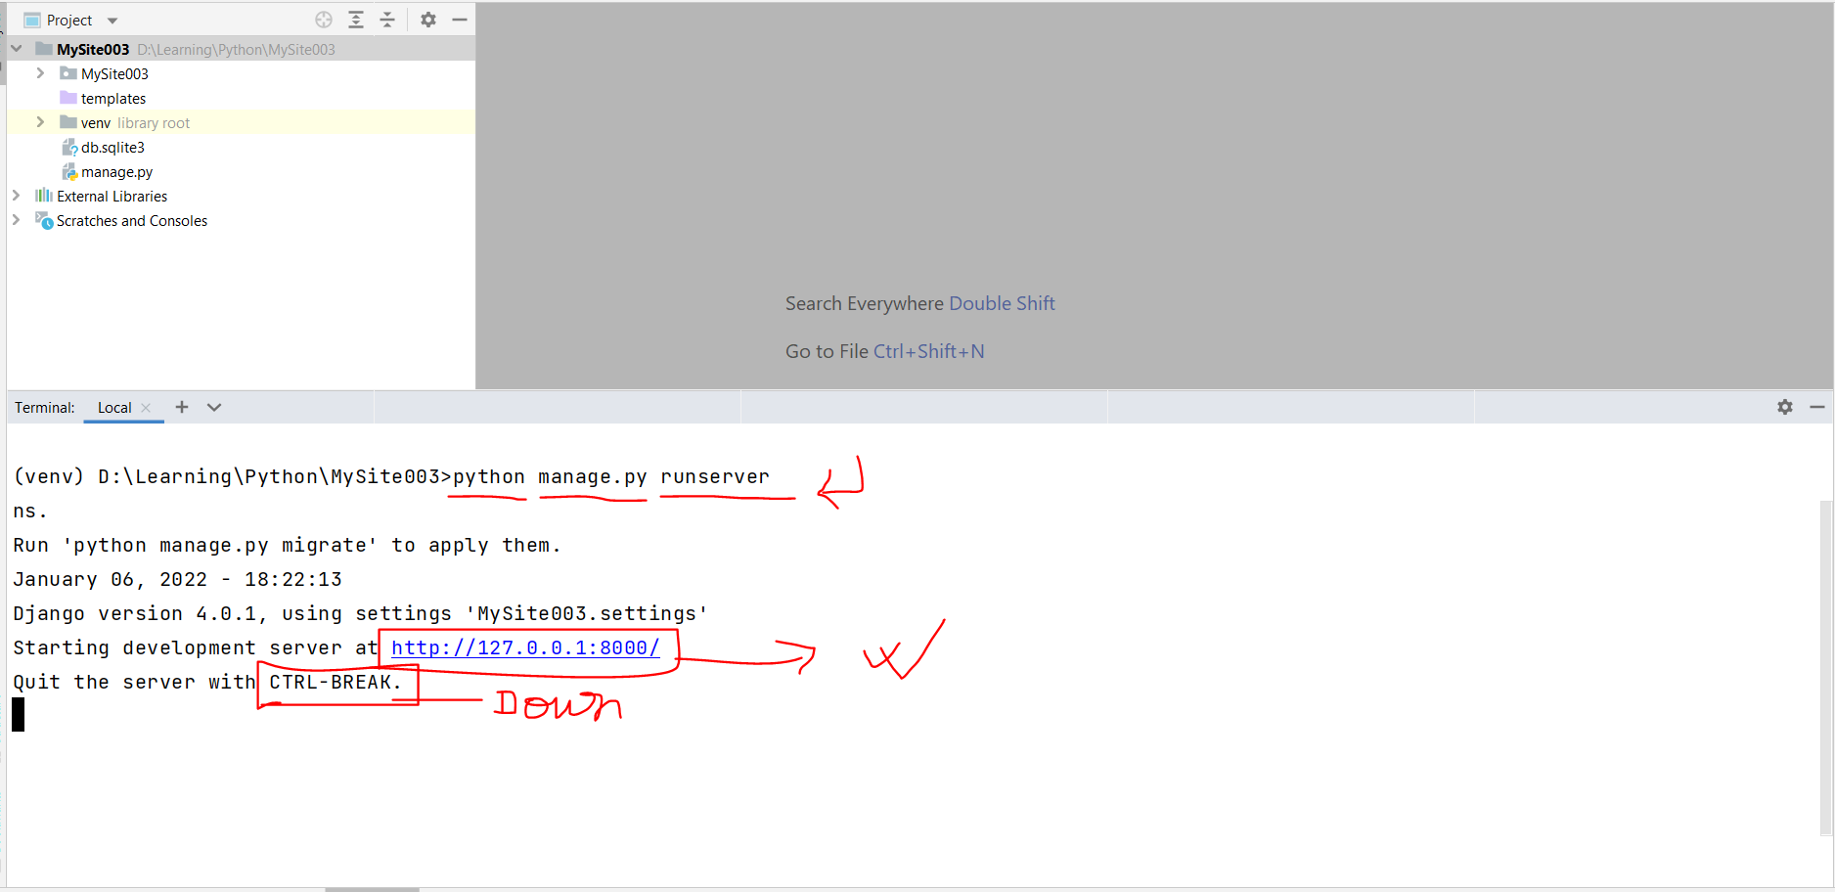

**Creating new app**

* Terminal > python manage.py startapp app1

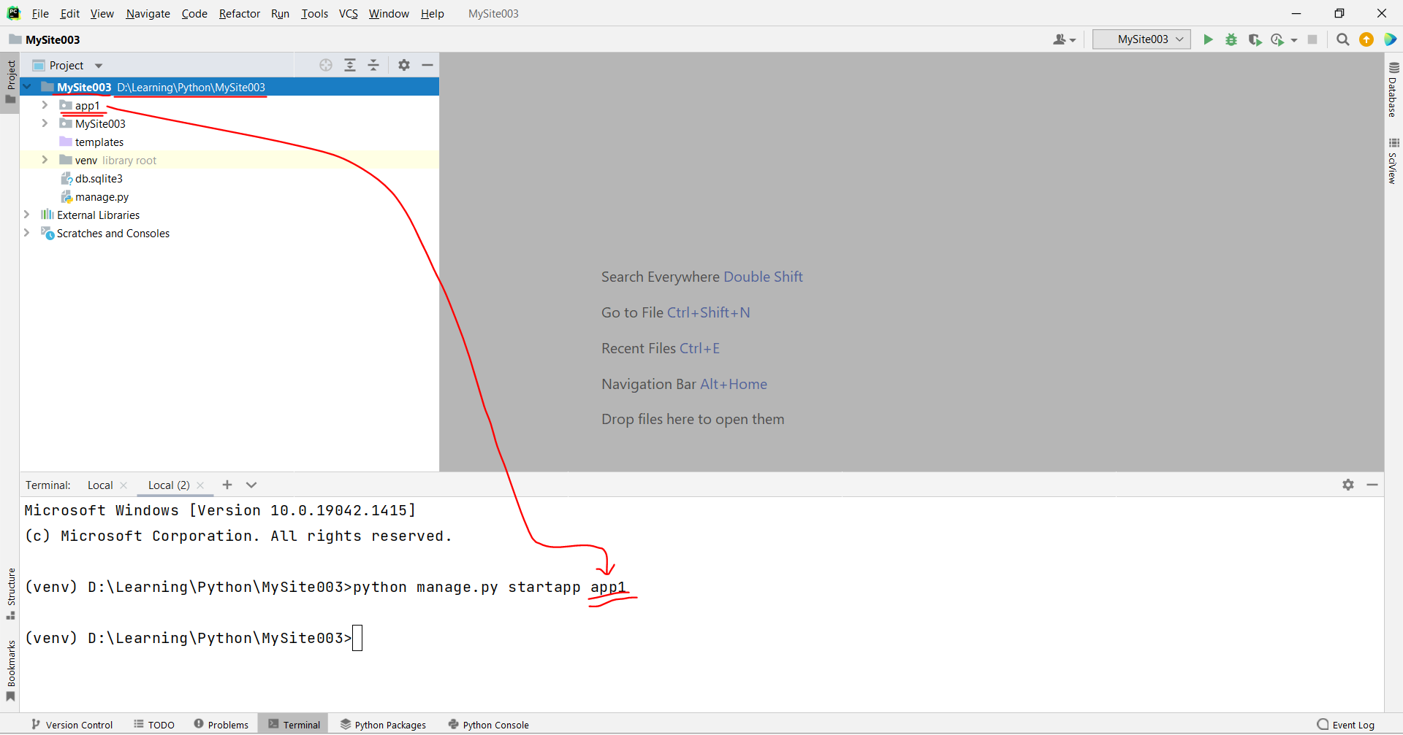

Note:

* input/process/output in web mode

**Register app in settings.py**

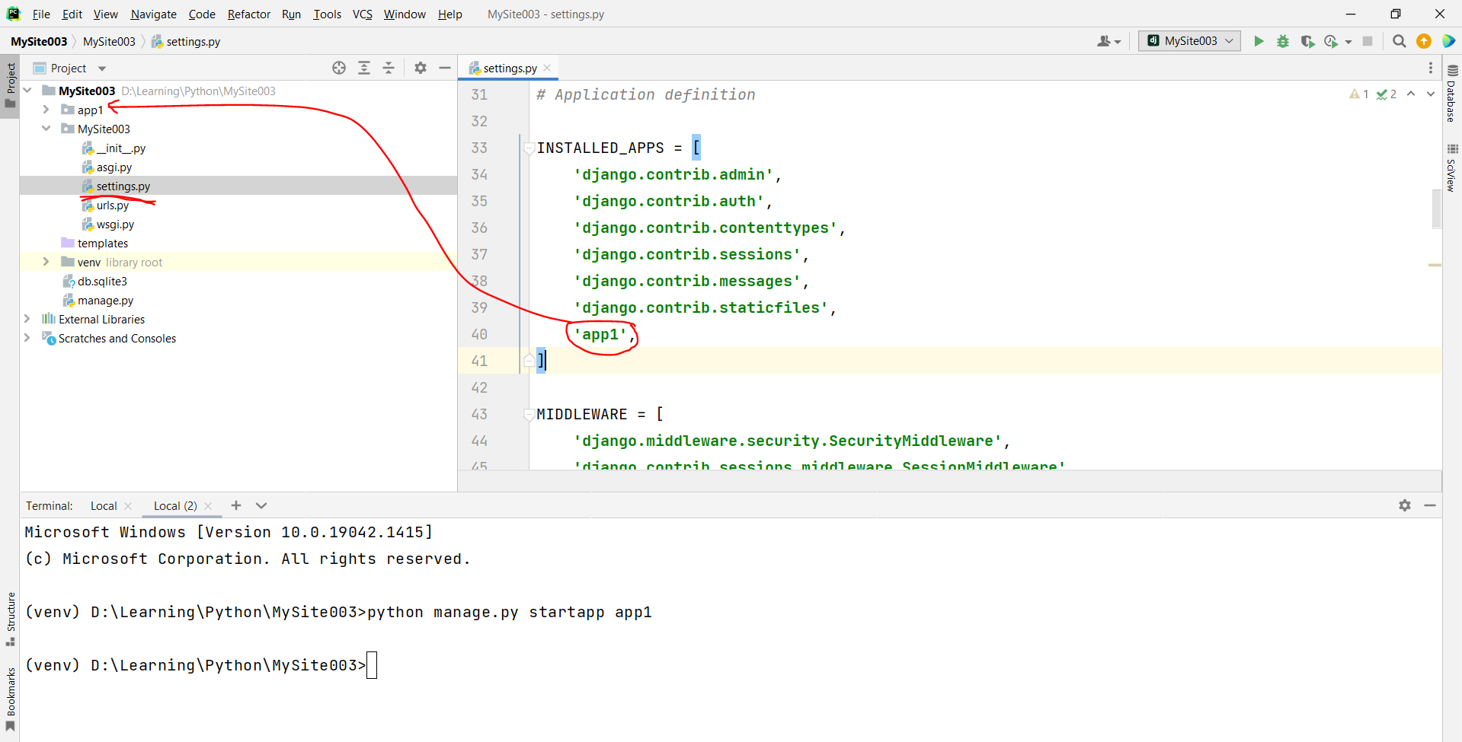

**Explore app**

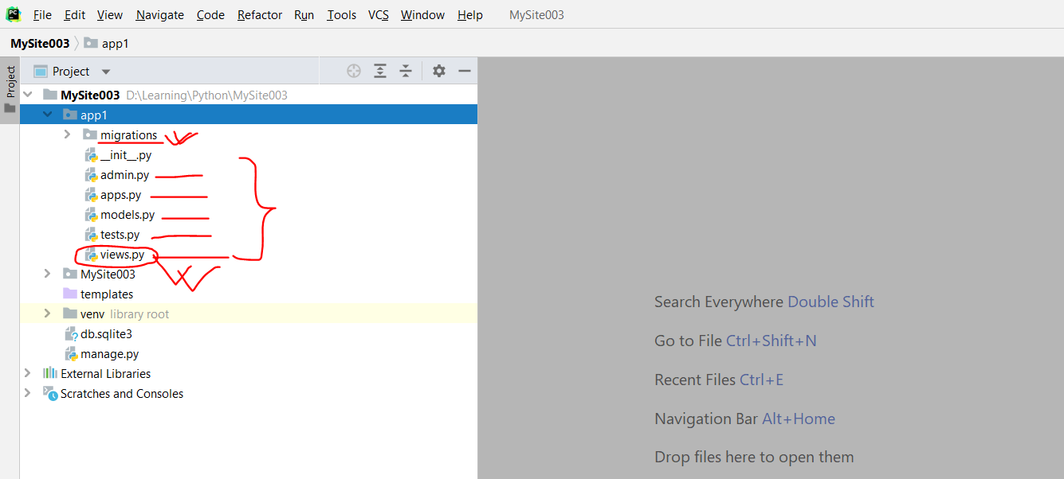

**Create new view (app1\views.py)**

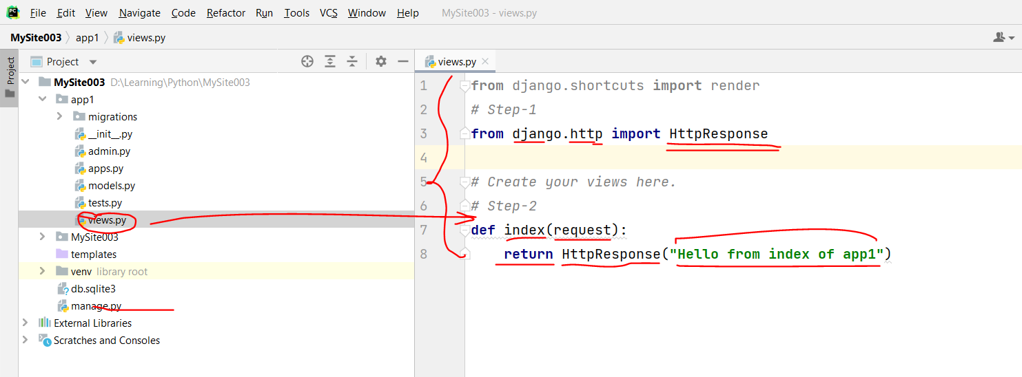

**Create urlpattern for view (views.index()) (MySite003\urls.py)**

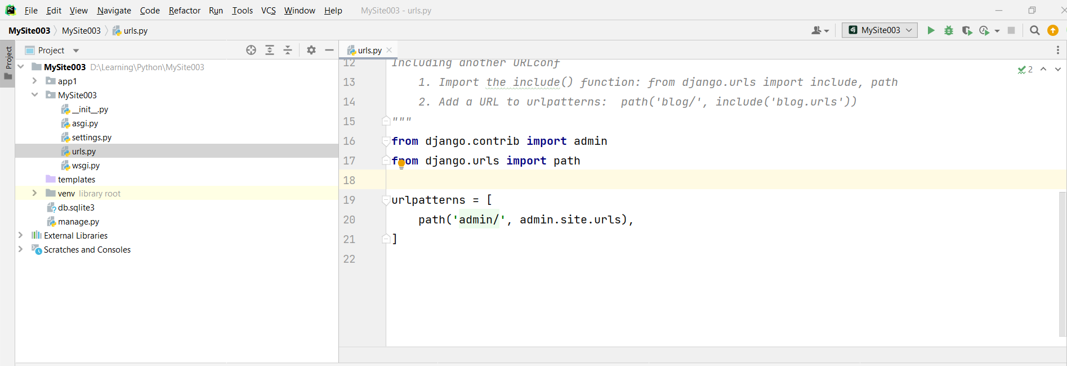

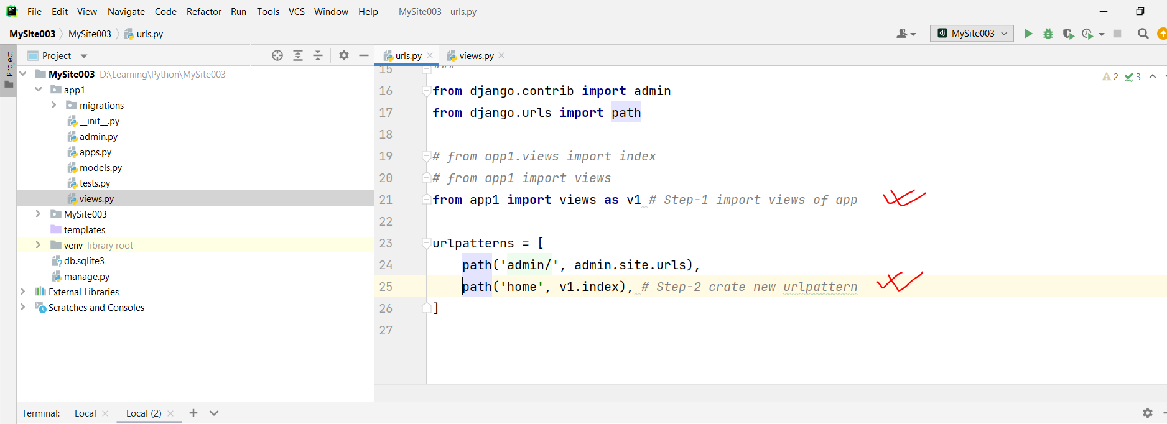

**Browse app**

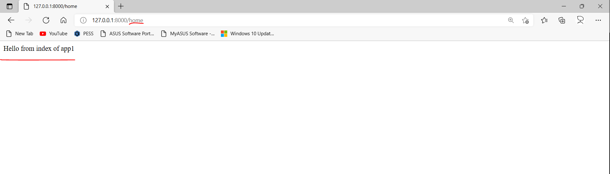

**Task-1: Create the following functions in views and url patterns and test.**

* Home
* About
* Products
* Gallery
* Contact